### 5.4 Windows Registry

Every software and hardware configuration is stored in a database called the registry. The registry contains such things as folder and file property settings, port configuration, application preferences, and user profiles. A user profile contains specific configuration settings such as the specific applications to which the user has access, desktop settings, and the user's network configuration for each person who has an account on the computer. The profile is different for each person who has an account on the computer. The registry loads into RAM (memory) during the boot process. When in memory, the registry is updated continuously by changes made to software, hardware, and user preferences.

The registry is divided into five subtrees. Subtrees are also sometimes called branches or hives. The five standard subtrees follow: **Hkey_Local_Machine**, **Hkey_Users**, **Hkey_Current_User**, **Hkey_Current_Config**, and **Hkey_Classes_Root**. Each of these subtrees has keys and subkeys that contain values related to hardware and software settings. The table below lists the five subtrees and their functions. The registry can contain other subtrees that are user-defined or system-defined, depending on what hardware or software is installed on the computer.

| **Registry subtree** | **Subtree function** |
| --- | --- |
| **Hkey_Local_Machine** | Holds global hardware configuration. Included in the branch is a list of hardware components installed in the computer, the software drivers that handle each component, and the settings for each device. This information is not user-specific. |
| **Hkey_Users** | Keeps track of individual users and their preferences. |
| **Hkey_Current_User** | Holds a specific user's configuration, such as software settings, how the desktop appears, and what folders the user has created. |
| **Hkey_Current_Config** | Holds information about the hardware profile that is used when the computer first boots. |
| **Hkey_Classes_Root** | Holds file associations and file links. The information held here is what allows the correct application to start when you double-click a filename in Windows Explorer/File Explorer or My Computer/Computer (provided that the file extension is registered). |

### Editing the Windows Registry

Most changes to Windows are done through the various Control Panels, but sometimes the only way to make a change is to edit the registry directly. Depending on the Windows operating system used, one or two registry editors are available from a command prompt: regedit and regedt32. Shown below is the Windows 7 **regedit** utility.

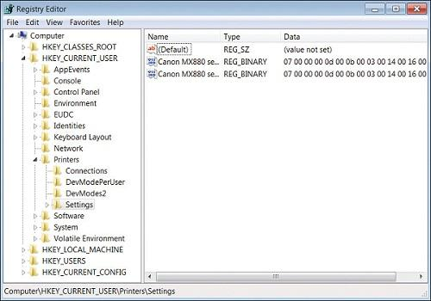

Notice in figure above that subtrees appear in the left window, such as **Hkey_Classes_Root** and **Hkey_Current_User**. If you click the arrow beside a subtree, more subkeys appear. After several layers, when you click a folder in the left window, values appear in the right window. These values are the ones you must sometimes change to fix a problem.

REGISTRY TERMINOLOGY

| **Registry term** | **Meaning** |
| --- | --- |
| Hive | A branch of the registry, which helps organize the keys into broader categories |
| Key | Analogous to a folder, it holds various values |
| Value | A registry setting, located inside a key |
| Data | Data to a value that signifies the state of the setting |
| REG_[type] | A value of type [type]. Type can be SZ for string, BINARY, DWORD (32-bit integer), MULTI_SZ (multiple strings), QWORD (64-bit integer), etc |

Tech Tip: Make a backup of the registry before you change it

Before making changes to the registry, you should make a backup of it. This way, if the changes do not work properly, the changes can be easily reversed.

For 64-bit versions of Windows, the registry is divided into 32- and 64-bit keys. The 32-bit keys are kept in a subfolder called *Wow6432Node*, located within the **Hkey_Local_Machine** key (*Software* folder). On some machines, the vendor may have a subfolder under *Software*; it is this vendor subfolder that contains the *Wow6432Node*folder. Just do a search for *Wow6432Node* to find it. 64-bit software keys are kept in **Hkey_Local_Machine\Software** subfolders.

Registry files are saves as .reg